**CHAPTER 1**

**INTRODUCTION**

In several decades, world economic growth has changed People’s lifestyle, leading to arise so many degenerative disease cases around the world. Brain tumour is one of the degenerative diseases that have been concerned by doctors and researchers to be investigated. Brain tumours statistically occur as a leading cause of cancer-related deaths in adult males/females and children as well. There are nearly 700,000 people in the U.S. living with a brain tumour, which meningioma represent 34% of all primary brain tumours, making them the most common primary brain tumour. In Indonesia, the number of brain tumour cases is only based on neurosurgeons experience or autopsy in hospitals and there is no accurate statistical data reporting about it. To treat patients with brain tumours without the use of neuroimaging is impossible to imagine. From this reason, researchers do efforts to develop neuroimaging modalities for selecting and developing appropriate therapy, detecting early treatment failure, and providing accurate and clinically relevant biologic end points for high-risk, but potentially high-reward, and tumour specific therapies tailored to the unique biology of an individual brain tumour. Magnetic resonance imaging (MRI), positron emission tomography (PET) and computed tomography (CT) are commonly used as modalities for neuroimaging, since those techniques provide accurate and high resolution results. However, the cost of MRI, PET or CT scanner is relatively still expensive, particularly in developing countries with high population like Indonesia. In addition, the complexity of MRI, PET or CT equipment is also become another issue for implementation in rural and isolated areas. Microwave has been widely investigated for medical imaging on moving organs and tissue containing water. Owing to its non-invasive characteristics leads to

1

easier conduct the evaluation and measurement. Some UWB antennas have been proposed for brain imaging

**1.1 BRAIN TUMOUR**

The brain is an important organ that controls thought, memory, emotion, touch, motor skills, vision, respiration, body temperature, hunger, and many other processes that regulate our body. The spinal cord is a large bundle of nerve fibers that extends from the base of the brain to the lower back. It carries messages to and from the brain and the rest of the body.

A brain tumour is a growth of abnormal cells inside the brain. Most brain tumours that children get are called primary brain tumours, meaning that they originated in the brain and did not spread from somewhere else. Tumours might be localized, remaining in one area, or they might be invasive, spreading into nearby tissues. Tumours are also categorized as benign (non-cancerous) or malignant (cancerous). However, it is difficult to call any brain tumour "benign", because all can cause serious problems.

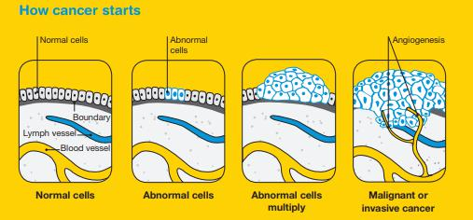

Fig 1.1 tumour development stages

2

**1.1.1 PARTS OF THE BRAIN**

The brain has 3 main parts:

**Cerebrum.** This is the upper (supratentorial) part of the brain. It’s composed of theright and left halves (hemispheres). Functions of the cerebrum include: language (spoken and written), initiation of movement, coordination of movement, processing of vision and hearing, judgment, reasoning, problem solving, emotions, and learning.

**Cerebellum.** This is the lower (infratentorial) part of the brain. It’s located at theback of the head, just above the neck. Its function is to coordinate voluntary muscle movements and to maintain posture, balance, and equilibrium.

**Brainstem.** The brainstem includes the midbrain, the pons, and the medulla.Functions of this area include: movement of the eyes and mouth, relaying sensory messages (hot, pain, loud, etc.), hunger, breathing, consciousness, cardiac function, body temperature, involuntary muscle movements, sneezing, coughing, vomiting, and swallowing.

**1.2 TYPES OF BRAIN TUMOUR**

**Benign tumour.** This kind of tumour is not cancer. It tends to grow slowly.Most benign brain tumours don’t grow into nearby tissue. Once removed, they usually don’t grow back. A benign tumour can cause symptoms like a malignant tumour depending on its size and location in the brain.

**Malignant tumour.** This kind of tumour is cancer. It usually grows fast, and growsinto nearby tissue. This can make it hard to remove fully. A malignant brain tumour may grow back after treatment.

3

Brain tumours can be classified into two general groups:

* Primary brain tumour
* Secondary brain tumour

**1.2.1 PRIMARY BRAIN TUMOUR**

Primary brain tumours are named by the type of brain tissue where they’re found. The most common type of primary brain tumour is a glioma. This type begins in the supportive (glial) tissue of the brain. Some gliomas tend to grow slowly. Others grow and spread quickly. Some types of glioma include:

**Astrocytoma.** This kind of tumour comes from small star-shaped cells calledastrocytes. In adults, an astrocytoma usually grows in the cerebrum. In children, they can grow in the cerebellum, cerebrum, and brain stem. Most astrocytomas spread into nearby normal brain tissue and are hard to cure with surgery. Glioblastoma is a type of astrocytoma that tends to grow very quickly.

**Brain stem glioma.** This kind of tumour of the brain stem is more common inchildren than in adults. Because the brain stem controls many important functions, such as breathing and heart rate, this kind of tumour usually can’t be removed by surgery.

**Ependymoma.** This kind of tumour starts in cells that line the fluid-filled spaceswithin the brain (ventricles). It doesn’t often grow into nearby brain tissue. This means in some cases it can be cured with surgery.

**Oligodendroglioma.** This kind of tumour starts in cells that make myelin, the fattysubstance that surrounds nerve cells. Like an astrocytoma, this tumour tends to spread into nearby brain tissue and is often hard to cure with surgery.

4

**Optic nerve glioma.** This kind of tumour grows in or around the nerve that sendsmessages from the eyes to the brain. This can cause vision changes. It can also cause hormone changes, due to its location near the pituitary gland. Other types of primary tumours include:

**Primitive Neuroectodermal Tumour (PNET).** This kind of tumour grows moreoften in children. It can grow anywhere in the brain in the primitive form of nerve cells. One type is the medulloblastoma. This kind of tumour is found in the cerebellum. They are more common in children than in adults. They tend to grow and spread quickly, but they can often be treated effectively.

**Tumour of the pineal gland.** This kind of tumour grows in and around the pinealgland. This is a tiny organ near the center of the brain. The tumour can be slow-growing, called pineocytoma. Or it can be fast-growing, called pineoblastoma.

**Pituitary tumour.** This kind of tumour starts in the pituitary gland at the base of thebrain. It is almost always benign. But it can cause serious symptoms because of its location, and because it may secrete excess hormones.

**Craniopharyngioma.** This kind of tumour starts near the pituitary gland. It isusually slow growing. But it can cause symptoms if it presses on the pituitary gland or on nearby nerves.

**Schwannoma.** This kind of tumour starts in myelin-making cells that surroundcertain nerves. It’s most common in the vestibular nerve in the inner ear that helps with balance. If it grows there, the tumour is called a vestibular schwannoma or an acoustic neuroma. This type of tumour is usually benign.

5

**Meningioma.** This kind of tumour starts in the outer linings of the brain (meninges).It is more common in adults. Many meningiomas can be removed with surgery, but some may grow back.

**Primary central nervous system lymphoma.** This is an aggressive, rare type oftumour that starts in lymphocytes. This is a type of immune cell. The tumour is more common in people with a disease of the immune system, such as AIDS. But it can grow in healthy people.

**1.2.2 SECONDARY BRAIN TUMOUR**

A secondary brain tumour is also known as a metastatic brain tumour. This is cancer that starts in another organ and then travels to the brain. In adults, secondary brain tumours are more common than primary brain tumours. Cancer in the brain that has spread from another part of the body is not considered brain cancer. It is still the same type of cancer as where it started. For example, lung cancer that has spread to the brain is called metastatic lung cancer.

These are some of the most common types of cancer that spread to the brain:

* Lung cancer
* Breast cancer
* Melanoma
* Colon cancer
* Kidney cancer

6

**1.3 OBJECTIVE**

The goal of our work is to design a modified UWB pentagon antenna, operating from 3.67-13.2 GHz in free space which is having the dimension of 44*30mm2 and suitable for microwave imaging especially for detecting brain Tumour. The tumour can be detected from the back-scattered signals. We also design and analyse the human head phantom model with and without tumour with the designed antenna. The statistical parameters like mean, variance, standard deviation, kurtosis, skewness etc., can be calculated from the obtained reflection coefficient values. For various sized tumour at different locations we are going to analyse the statistical parameters with the obtained results we are going to find the presence of tumour in the brain.

7

**CHAPTER 2**

**LITERATURE SURVEY**

**2.1 INTRODUCTION**

Literature review is an assignment of previous task done by various authors and collection of information or data from research papers published in journals to progress our task. There are lot of literatures published before on the same task. Some papers are taken into consideration from which idea of the project is taken.

**2.2 WORK PROPOSED BY VARIOUS AUTHORS**

Haoyu Zhang, Brian Flynn, Ahmet T. Erdogan, Tughrul Arslan have proposed an ultra-wide-Band (UWB) Vivaldi Antenna array is used for microwave imaging based brain cancer detection. A cancerous brain model which consists of a 5 mm tumour and four layers is simulated with CST Microwave Studio. The input pulse is radiated into brain model and the pulse response is recorded by the receiver antenna. The analytical signal function has been employed to eliminate the noise and the scanning method is applied for microwave imaging. The image processing result shows a good agreement with the actual tumour location in the brain model.

CONCLUSION: A microwave imaging for brain cancer detection has been presented and simulated. It shows that the receiver antenna receives more energy when pointed at the tumour. Using this knowledge, the tumour location can be determined by rotating the antenna array to scan the head. The analytical signal and peak detection method has been employed to eliminate the noise and distinguish the tumour reflection. 49 sets of received signal have been collected and processed. The resulting image shows that a tumour inside a brain can be detected by this method [10].

8

Mohammed A. Alzabidi, Maged A. Aldhaeebi and Ibrahim Elshafiey have proposed an UWB Vivaldi Antenna structure is presented and analyzed for tumour detection of brain cancer. Various antenna configurations are considered in this analysis. The radiation is investigated inside a human head phantom with a tumour model. The antenna is designed with FR-4 substrate, and is tested when immersed in background of relative permittivity 40 to achieve good matching with the head tissue. Results show that good performance is obtained for the design size of 329.25x153x1.6 mm, and the antenna is found to operate in the range 100 MHz to 1.4 GHz.

CONCLUSION: In this paper, An UWB Vivaldi Antenna is optimized for operation in microwave imaging for tumour detection. Various structures are developed. Simulation provide effective tool to optimize the design of the antenna and thus maximize the energy interaction with the tissues to be detected [15].

Adhitya Satria Pratama, Basari, Muhammad Firdaus S. Lubis, Fitri Yuli Zulkifli, Eko Tjipto Rahardjo proposed an ultrawideband (UWB) antenna is proposed as a transceiver of microwave imaging on brain tumours, which it operates in UWB range (i.e. 3.1–10.6 GHz). The proposed antenna is a printed dipole-like fed by a coplanar waveguide because it provides high frequency response. The antenna is numerically simulated using CST Microwave Studio 2014 and experimentally measured near to a semi-solid head-equivalent phantom, particularly S11 and radiation pattern on xy- and yz-plane at 5.8 GHz.

CONCLUSION: A UWB dipole-like antenna fed by CPW technique has been proposed to meet 3.1–10.6 GHz of UWB operating band. Small size of the antenna is obtained, which is fabricated on low cost FR-4 substrate. The proposed antenna is located in proximity to a homogenous head equivalent phantom to simulate the head imaging. The measurement is conducted to confirm the simulation results, in

9

particular in terms of the S11 and the radiation characteristics. The results show good agreement between measured and simulated results [1].

M. A. Shokry*, Prof. Dr. A. M. M. A. Allam have designed an UWB Pentagon antenna is designed to detect brain stroke and brain tumour. It is operating at a band from 3.3568- 12.604 GHz in free space and from 3.818 to 9.16 GHz on the normal head model. The antenna has dimensions of 44x30mm2. It is fabricated on FR4-substrate with relative permittivity 4.4 and thickness 1.5mm. The antenna is simulated on the CST Microwave Studio and measured using the network analyser.

There is a good agreement between the measured and simulated results of the return loss of the antenna on human’s head and head phantom.

CONCLUSION: The paper illustrates the design and implementation of a pentagon antenna for brain cancer and stroke detection, positioned directly on human’s head. It is simulated using CST microwave studio and fabricated on FR-4 substrate with relative permittivity 4.4 and thickness 1.5mm. It is pointed out that there is a frequency shift of 213 MHz between the normal head model and the one simulated with tumour while a shift of 218MHz when simulated on head model with stroke. The pentagon antenna is also measured on a normal head phantom. It is clear that there is a good agreement between the measured and simulated results [13].

10

**CHAPTER 3**

**FUNDAMENTAL PPARAMETERS OF THE ANTENNA**

**3.1 INTRODUCTION**

The fundamental terms gives a description of the parameters being analysed for an antenna design. This chapter also gives detailed description of the techniques used for the proposed design.

**3.2 ANTENNA BASICS**

An antenna is an important component in the communication system. Basically antennas are the metal structures designed for radiating and receiving electromagnetic energy in an efficient manner which is used for conveying the information.

Different types of applications requires antenna with the different parameters like for cellular mobile communication a circular polarised antenna is required with high gain and for satellite communication in downlink a high directive antenna is required.

**3.3 ANTENNA PARAMETERS**

The choice of a particular antenna depends on the factors such as gain, radiation pattern, polarization, bandwidth, resonant frequency and impedance. The antenna parameters such as gain, resonant frequency, impedance etc., Define the performance of the antenna.

11

**3.3.1 BANDWIDTH**

The bandwidth of an antenna refers to the range of frequencies over which the antenna can operate correctly. The bandwidth can a range of frequencies on either sides of the centre frequency on either sides of the centre frequency where the antenna characteristics like input impedance, radiation pattern, beam width, polarization, side lobe level or gain are close to those values which have been obtained at the centre frequency.

BW =

FH – FL

------------

FC

(3.1)

Where FH is the highest frequency in the band, FL is the lowest frequency in the band, and FC is the centre frequency in the band. In this way, bandwidth is constant relative to frequency. If bandwidth was expressed in absolute units of frequency, it would be different depending upon the centre frequency. Different types of antennas have different bandwidth limitations.

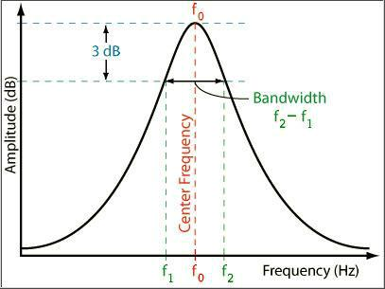

Fig 3.1 antenna bandwidth

12

**3.3.2 RETURN LOSS**

The return loss is another way of expressing mismatch. It is the logarithmic ratio measured in dB that compares the power reflected by the antenna to the power that is feed into the antenna from the transmission line. The relationship between the SWR and return loss is given as following.

SWR

Return loss (dB) = 20 log 10 ------------

SWR-1

(3.2)

**3.3.3 GAIN**

An antenna's power gain or simply gain is a key performance number which combines the antenna's directivity and electrical efficiency. In a transmitting antenna, the gain describes how well the antenna converts input power into radio waves headed in a specified direction.

In a receiving antenna, the gain describes how well the antenna converts radio waves arriving from a specified direction into electrical power. When no direction is specified, "gain" is understood to refer to the peak value of the gain, the gain in the direction of the antenna's main lobe. A plot of the gain as a function of direction is called the radiation pattern.

Antenna gain is usually defined as the ratio of the power produced by the antenna from a far-field source on the antenna's beam axis to the power produced by a hypothetical lossless isotropic antenna, which is equally sensitive to signals from all directions. Usually this ratio is expressed in decibels. An alternative definition compares the received power to the power received by a lossless half wave dipole antenna, in which case the units are written as *dBd*. Since a lossless dipole antenna has a gain of 2.15 dBi, the relation between these units is.

13

|  |  |
| --- | --- |
| Gain (dBd) = Gain (dBi) – 2.5 | (3.3) |



dBi – Decibels referenced to an isotropic antenna

dBd – decibels referenced to half wavelength dipole

**3.3.4 DIRECTIVITY**

The directivity of an antenna or array is a measure of the antenna‘s ability to focus the energy in one or more specific directions. You can determine an antenna‘s directivity by looking at its radiation pattern. In an array propagating a given amount of energy, more radiation takes place in certain directions than in others. The elements in the array can be arranged so they change the pattern and distribute the energy more evenly in all directions. The opposite is also possible. The elements can be arranged so the radiated energy is focused in one direction. The elements can be considered as a group of antennas fed from a common source. It is defined as the ratio of maximum radiation intensity of subject or test antenna to the radiation intensity of an isotropic antenna. (or) Directivity is defined as the ratio of maximum radiation intensity to the average radiation intensity. Directivity (D) in terms of total power radiated is,

Maximum radiation intensity

|  |  |
| --- | --- |
| D = | (3.4) |



Total power radiated

**3.3.5 RESONANT FREQUENCY**

This is the frequency where the capacitive and inductive reactances cancel each other out. At this point the RF antenna appears purely resistive, the resistance being a combination of the loss resistance and the radiation resistance.

14

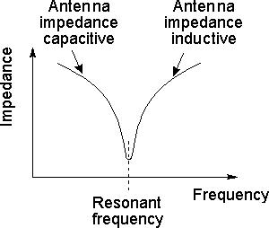

Fig 3.2 Impedance of an RF antenna with frequency

The capacitance and inductance of an RF antenna are determined by its physical properties and the environment where it is located. The major feature of the RF antenna design is its dimensions. It is found that the larger the antenna or more strictly the antenna elements, the lower the resonant frequency. For example antennas for UHF terrestrial television have relatively small elements, while those for VHF broadcast sound FM have larger elements indicating a lower frequency. Antennas for short wave applications are larger still.

**3.3.6 IMPEDENCE**

Antenna impedance is a measure of the resistance to an electrical signal in an antenna. Many factors have an impact on an antenna’s ability to transmit a signal, including the environment that the antenna is in and the design and composition of the antenna. The ratio of voltage to current, which is equal to antenna impedance, is expressed in units called ohms. The antenna impedance represents the power that is absorbed by the antenna as well as the power that is dispersed by it as it comes into contact with an electromagnetic wave. Different wavelengths of electromagnetic radiation will give the same antenna different impedance values. In electronics, ohms are a measure of the resistance within a wire, and a measurement of zero ohms means

15

that there is no resistance, while a measurement of infinite ohms indicates that there is complete resistance. The antenna impedance would be zero ohms if the voltage and the current stayed the same from one point in the antenna to another. This is never the case in real-world antennas, however, which generally have an impedance of somewhere between 15 and 1,000 ohms.

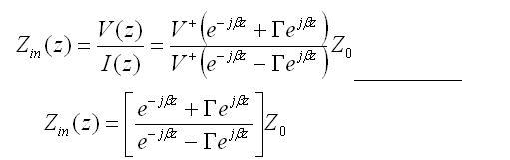

(3.5)

**3.3.7 RADIATION PATTERN**

The radiation pattern or antenna pattern is the graphical representation of the radiation properties of the antenna as a function of space. That is, the antenna's pattern describes how the antenna radiates energy out into space (or how it receives energy). It is important to state that an antenna radiates energy in all directions, at least to some extent, so the antenna pattern is actually three-dimensional. It is common, however, to describe this 3D pattern with two planar patterns, called the principal plane patterns. These principal plane patterns can be obtained by making two slices through the 3D pattern through the maximum value of the pattern or by direct measurement. It is these principal plane patterns that are commonly referred to as the antenna patterns.

16

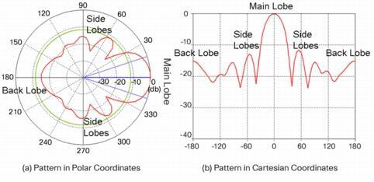

Fig 3. 3 Radiation Patterns in Polar and Cartesian Coordinates Showing Various Types of Lobes

**3.3.8 VSWR**

VSWR stands for Voltage Standing Wave Ratio, and is also referred to as Standing Wave Ratio (SWR). VSWR is a function of the reflection coefficient, which describes the power reflected from the antenna. If the reflection coefficient is given by , then the VSWR is defined by the following formula:



(3.6)



The VSWR is always a real and positive number for antennas. The smaller the VSWR is, the better the antenna is matched to the transmission line and the more power is delivered to the antenna. The minimum VSWR is 1.0. In this case, no power is reflected from the antenna, which is ideal.

**3.3.9 POLARIZARION**

An antenna is a transducer that converts radio frequency electric current to electromagnetic waves that are then radiated into space. The electric field or "E"

17

plane determines the polarization or orientation of the radio wave. In general, most antennas radiate either linear or circular polarization. A linear polarized antenna radiates wholly in one plane containing the direction of propa gation. In a circular polarized antenna, the plane of polarization rotates in a circle making one complete revolution during one period of the wave. If the rotation is clockwise looking in the direction of propagation, the sense is called right-hand-circular (RHC). If the rotation is counterclockwise, the sense is called left-hand-circular (LHC).

An antenna is said to be vertically polarized (linear) when its electric field is perpendicular to the Earth's surface. An example of a vertical antenna is a broadcast tower for AM radio or the "whip" antenna on an automobile. Horizontally polarized (linear) antennas have their electric field parallel to the Earth's surface. Television transmissions in the USA use horizontal polarization.

A circular polarized wave radiates energy in both the horizontal and vertical planes and all planes in between. The difference, if any, between the maximum and the minimum peaks as the antenna is rotated through all angles, is called the axial ratio or ellipticity and is usually specified in decibels (dB). If the axial ratio is near 0 dB, the antenna is said to be circular polarized. If the axial ratio is greater than 1-2 dB, the polarization is often referred to as elliptical.

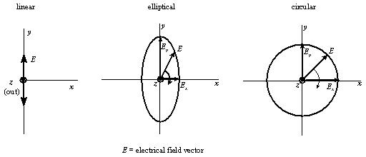

Fig 3.4 Types of polarization

18

**3.4 THEORY OF MICROSTRIP ANTENNA**

Microstrip patch antennas possess a very high antenna quality factor (Q) which represents the losses associated with the antenna where a large Q would lead to a narrow bandwidth and low efficiency. The factor Q can be reduced by increasing the thickness of the dielectric substrate but as the thickness will increase there will be a simultaneous increase in the fraction of the total power delivered by the source into a surface wave which can be effectively considered as an unwanted power loss since it is ultimately scattered at the dielectric bends and causes degradation of the antenna characteristics. Other problems such as lower gain and lower power handling capacity can be overcome by using an array configuration for the elements which is a collection of homogeneous antennas oriented similarly to get greater directivity and gain in a desired direction. The inset-fed microstrip antenna provides impedance control with a planar feed configuration.

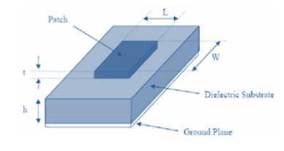

Fig 3.5 microstrip patch antenna

The structure of the Micro strip patch antenna consists of a thin square patch on one side of a dielectric substrate and the other side having a plane to the ground. In its most fundamental form, a Micro strip antenna consists of a radiating patch on one side of a dielectric substrate which has a ground plane on other side as shown in the figure below. The patch is generally made of conducting material such as copper or gold. The basic antenna element is a strip conductor of length L and width W, on a

19

dielectric substrate. The thickness of the patch being h with a height and thickness t

is supported by a ground plane. The rectangular patch antenna is designed so that it

can operate at the resonance frequency.

**3.4.1 DESIGN SPECIFICATIONS**

The essential parameters for the design of a rectangular Microstrip Patch Antenna are:

1. Calculation of width (W):

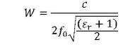

(3.7)



Where,

= Width of the patch

o= Speed of light (3×108m/s)

* + value of the dielectric substrate

1. Calculation of effective Dielectric constant (εreff )

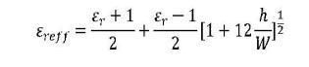

(3.8)



* + Width of the patch

1. Calculation extension Length:

It is used for calculating resonant frequency of Microstrip antenna.

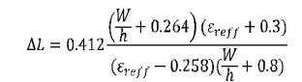

(3.9)



20

* + Width of the patch

1. Calculation of Length (L)

Effective Length (Leff):

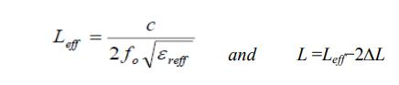

(3.10)



Where,

Ԑreff- Effective dielectric constant

5. Gain

The Gain of an antenna is given by

(3.11)



Where,

η- Efficiency

A- Physical aperture area

λ- Wavelength

6. Directivity

The directivity of an antenna is given by

(3.12)



Where,

η- Efficiency

A- Physical aperture area

* - Wavelength

21

**3.4.2 RADIATION MECHANISMS**

Radiation from microstrip antenna can be understood by considering the simple case of a rectangular microstrip patch spaced a small fraction of a wavelength above the ground plane as shown in the fig.3.6. Assuming no variation of the electric field along the width and the thickness of the microstrip structure, the electric field configuration of the radiator can be represented as shown in the fig 3.7. The field varies along the patch length which is about half a wavelength. Radiation may be ascribed mostly to the fringing fields at the open circuited edge of the patch. The field at the end can be resolved into the normal and tangential component with respect to the ground plane. The normal components are out of phase because the patch line is λ/2 long. Therefore the far field produced by them cancels in the broadside direction. The tangential components which are parallel to the ground plane are in phase and the resulting fields combine to give maximum radiated field normal to the surface of the structure. Therefore the patch may be represented by two slots λ/2 apart excited in phase and radiating in half space above the ground plane.

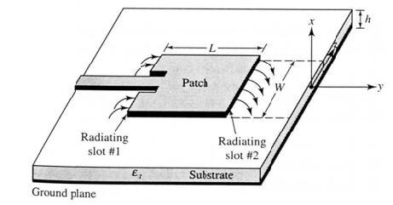

Fig 3.6 Rectangular mictrostrip patch antenna

22

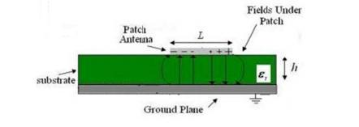

Fig 3.7 side view

**3.4.3 ADVANTAGES AND DISADVANTAGES**

ADVANTAGES

* They operate at microwave frequencies where traditional antennas are not feasible to be designed.
* This antenna type has smaller size and hence will provide small size end devices.
* The microstrip based antennas are easily etched on any PCB and will also provide easy access for troubleshooting during design and development. This is due to the fact that microstrip pattern is visible and accessible from top. Hence they are easy to fabricate and comfortable on curved parts of the device. Hence it is easy to integrate them with MICs or MMICs.
* As the patch antennas are fed along centre line to symmetry, it minimizes excitation of other undesired modes.
* The microstrip patches of various shapes e.g. rectangular, square, triangular etc. are easily etched.
* They have lower fabrication cost and hence they can be mass manufactured.
* They are capable of supporting multiple frequency bands (dual, triple).
* They support dual polarization types viz. linear and circular both.

23

* They are light in weight.
* They are robust when mounted on rigid surfaces of the devices.

DISADVANTAGES

* The spurious radiation exists in various microstrip based antennas such as microstrip patch antenna, microstrip slot antenna and printed dipole antenna.
* It offers low efficiency due to dielectric losses and conductor losses.
* It offers lower gain.
* It has higher level of cross polarization radiation.
* It has lower power handling capability.
* It has inherently lower impedance bandwidth.
* The microstrip antenna structure radiates from feeds and other junction points.

**3.4.4 APPLICATIONS OF MICROSTRIPE ANTENNA**

The Microstrip patch antennas are well known for their performance and their robust design, fabrication and their extent usage. The advantages of this Microstrip patch antenna are to overcome their de-merits such as easy to design, light weight etc., the applications are in the various fields such as in the medical applications, satellites and of course even in the military systems just like in the rockets, aircrafts missiles etc. the usage of the Microstrip antennas are spreading widely in all the fields and areas and now they are booming in the commercial aspects due to their low cost of the substrate material and the fabrication. It is also expected that due to the increasing usage of the patch antennas in the wide range this could take over the usage of the conventional antennas for the maximum applications. Microstrip patch antenna has several applications. Some of these applications are discussed as below:

24

3.4.4.1 MOBILE AND SATELLITE COMMUNICATION APPLICATION:

Mobile communication requires small, low-cost, low profile antennas. Microstrip patch antenna meets all requirements and various types of microstrip antennas have been designed for use in mobile communication systems. In case of satellite communication circularly polarized radiation patterns are required and can be realized using either square or circular patch with one or two feed points.

3.4.4.2 GLOBAL POSITIONING SYSTEM APPLICATIONS:

Nowadays microstrip patch antennas with substrate having high permittivity sintered material are used for global positioning system. These antennas are circularly polarized, very compact and quite expensive due to its positioning. It is expected that millions of GPS receivers will be used by the general population for land vehicles, aircraft and maritime vessels to find there position accurately.

3.4.4.3 RADIO FREQUENCY IDENTIFICATION (RFID):

RFID uses in different areas like mobile communication, logistics, manufacturing, transportation and health care [2]. RFID system generally uses frequencies between 30 Hz and 5.8 GHz depending on its applications. Basically RFID system is a tag or transponder and a transceiver or reader.

3.4.4.4 WORLDWIDE INTEROPERABILITY FOR MICROWAVE ACCESS (WIMAX):

The IEEE 802.16 standard is known as WiMax. It can reach up to 30 mile radius theoretically and data rate 70 Mbps. MPA generates three resonant modes at 2.7, 3.3 and 5.3 GHz and can, therefore, be used in WiMax compliant communication equipment.

25

3.4.4.5 RADAR APPLICATION:

Radar can be used for detecting moving targets such as people and vehicles. It demands a low profile, light weight antenna subsystem, the microstrip antennas are an ideal choice. The fabrication technology based on photolithography enables the bulk production of microstrip antenna with repeatable performance at a lower cost in a lesser time frame as compared to the conventional antennas.

3.4.4.6 TELEMEDICINE APPLICATION:

In telemedicine application antenna is operating at 2.45 GHz. Wearable microstrip antenna is suitable for Wireless Body Area Network (WBAN). The proposed antenna achieved a higher gain and front to back ratio compared to the other antennas, in addition to the semi directional radiation pattern which is preferred over the omni-directional pattern to overcome unnecessary radiation to the user's body and satisfies the requirement for on-body and off-body applications. A antenna having gain of 6.7 dB and a F/B ratio of 11.7 dB and resonates at 2.45GHz is suitable for telemedicine applications.

3.4.4.7 MEDICINAL APPLICATIONS OF PATCH:

It is found that in the treatment of malignant tumours the microwave energy is said to be the most effective way of inducing hyperthermia. The design of the particular radiator which is to be used for this purpose should posses light weight, easy in handling and to be rugged. Only the patch radiator fulfils these requirements. The initial designs for the Microstrip radiator for inducing hyperthermia was based on the printed dipoles and annular rings which were designed on S-band. And later on the design was based on the circular microstrip disk at L-band. There is a simple operation that goes on with the instrument; two coupled Microstrip lines are

26

separated with a flexible separation which is used to measure the temperature inside the human body. A flexible patch applicator can be seen in the figure below which operates at 430 MHz.

**3.5 FEEDING METHODS**

The excitation of the radiating element is an essential and important factor, which requires careful consideration in designing a most appropriate antenna for a particular application. A wide variety of feed mechanisms are available, not just for coupling energy to individual elements, but also for the controlled distribution of energy to linear or planner array elements.

The feed element may be either co-planer with the radiating elements, or situated in a separate transmission-line layer. Therefore, a brief over view of only four most popular Microstrip Antenna Feed techniques are given. These are namely:

* Microstrip line
* Co-axial Probe
* Aperture coupling
* Proximity coupling.

3.5.1 MICROSTRIP LINE FEED

Microstrip line feed is based on the principle that cutting an inset in the patch does not significantly affect the resonant frequency but that it modifies the input impedance. By properly selecting the depth of the inset, one can match the path to the transmission line without additional matching elements. The feed was the first used for practical applications and is the simplest way to feed a microstrip patch is to

27

connect a microstrip line directly to the edge of the patch, with both elements located on the same substrate. A microstrip line feed is shown in figure.3.8.

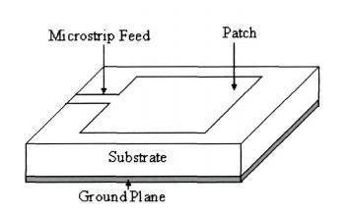

Fig 3.8 Microstrip patch antenna with microstrip line feed.

The microstrip line feed though simple in nature but a microstrip structure with the line and patch cannot be optimized simultaneously as an antenna and a transmission line. There must be some compromise between the two so that feed line does not radiate too much at the discontinuities [89]. The spurious radiation and the accumulated reactive power below the patch (cavity effect), degrades the antenna performance and reduces its bandwidth.

3.5.2 CO-AXIAL LINE FEED

Co-axial line feed was among the first considered and even today one of the most popular in many application of microstrip patch antenna. In co-axial line feed, the inner conductor of the coax is extends across the dielectric substrate and is connected to the patch while the outer conductor is connected to the ground plane as shown in the figure 3.9

28

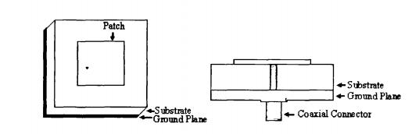

Fig 3.9 Microstrip Patch antenna with coaxial line feed.

In case of coaxial line feed the intrinsic radiation from the feed is small and can be neglected for thin substrates but becomes significant with thicker substrates. Now, most of the theoretical developments consider coaxial feeds and models were developed to characterize the injection of current in to patch accurately. However, coaxial feeds are difficult to realize in practice because drilling or punching holes through the substrate in a particular specific point is critical task, generally this operation would like to avoid. Again introducing the conductor through the holes and soldered to the patch are delicate operations that require careful handling, and mechanical control of the connection is difficult, especially for very high frequencies.

3.5.3 APERTURE COUPLING

In a conventional aperture coupling, the microstrip patch antenna consists of two substrate layers separated by a common ground plane. The radiating microstrip layer on the top of the substrate is fed trough an aperture in the ground plane by a microstrip feed line lying on the bottom of the lower substrate. The important requirement is that the common ground plane should contain etched apertures accurately positioned below the microstrip patch and above the feed line. Figure 3.10 shows an Aperture coupled feed microstrip patch antenna.

29

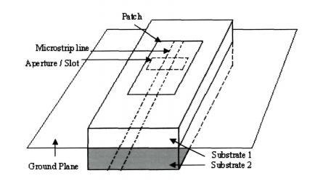

Fig 3.10 Aperture coupled feed microstrip patch antenna.

The aperture coupled feed technique has many attractive features; one is it provides stronger coupling than a similar triplet or suspended stripline system because of higher concentration of fields above the feed line where the aperture is positioned. Furthermore, a relatively high-permittivity substrate can be used if required for the feed system, without compromising the radiating properties of the lower-permittivity substrate carrying the microstrip patches. In this technique, the slot on the common ground plane is free to radiate bidirectionally. By using multilayer substrate, it can be made unidirectional radiation, but may result in strongly coupled surface wave modes which degraded in the antenna efficiency.

3.5.4 PROXIMITY COUPLING

In this feeding technique, the coupling of the patch and the feed line is obtained by placing the patch and the feed at different substrate levels. A thin layer of high dielectric constant substrate is used to reduce the radiation from the feed lines, where as a thick layer of low dielectric constant substrate is used in the upper layer to increase the radiation of the patch. The length of the feeding stub and the width-to-line ratio of the path can be used to control the match. Using the proximity

30

coupling, the frequency band width of a patch resonator could be significantly widened. The special feature is that, the feed line is no longer located to an open surface and there is no need to solder different conductors, unlike co-axial feed. The resulting structure becomes more complex to build, with two dielectric layers instead of one. Again one cannot easily connect components within the feeding circuit as it is buried inside substrate.

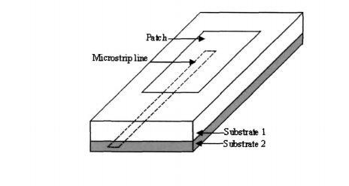

Fig 3.11 Proximity couple feed microstrip patch antenna

31

**CHAPTER 4**

**PROPOSED METHODOLOGY**

**4.1 UWB PENTAGON ANTENNA**

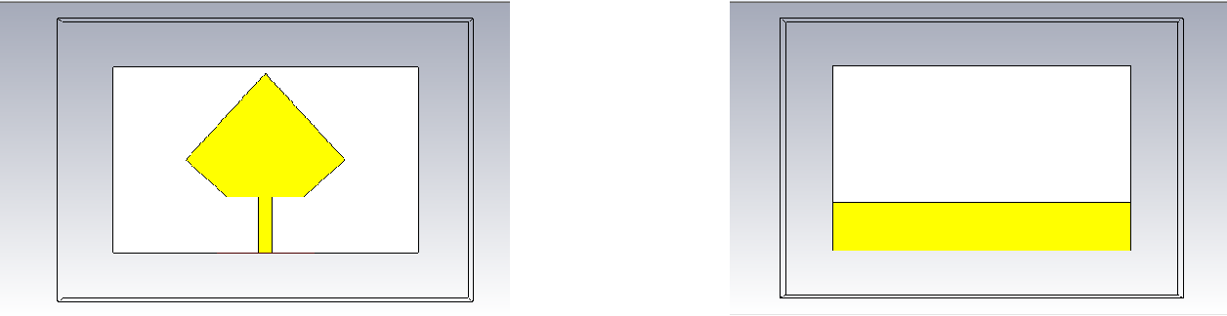

(a) (b)

Fig 4.1(a) Front view of the designed antenna (b) Back view of the designed antenna The design includes rectangular ground and substrate. The patch of the antenna

is pentagon shaped. The bottom part of the patch is fed with the microstrip feed.

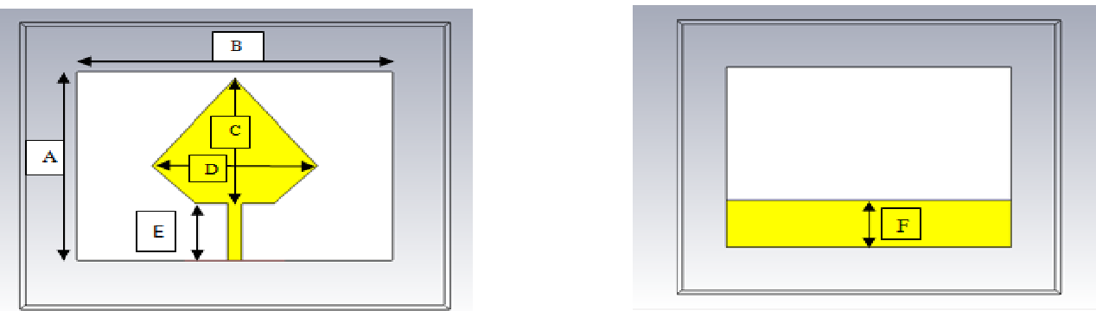

Fig 4.2 The above figure shows the patch and ground of the designed antenna.

The various dimensions of the patch and ground are shown below.

|  |  |
| --- | --- |
| Dimensions | Length in mm |
| A | 30 |
| B | 44 |
| C | 20 |
| D | 23 |
| E | 8.58 |
| F | 7.8 |

Table 4.1 Dimensions of existing uwb pentagon antenna

32

4.1.1SIMULATION RESULT:

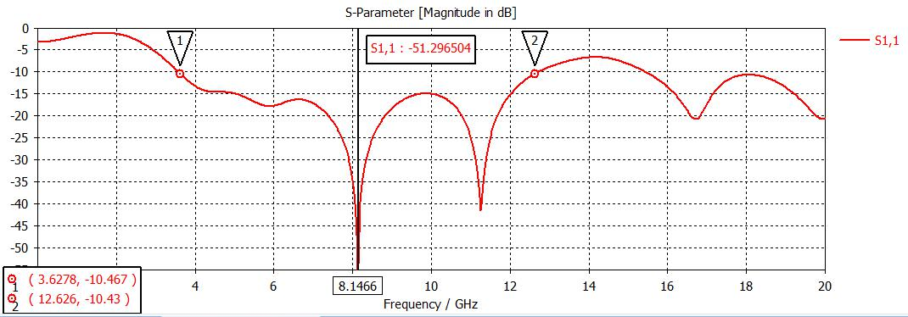

Fig 4.3 reflection coefficient of the designed antenna

From the above graph it is shown that the designed antenna radiates over the bandwidth of 3.62GHz to 12.626GHz with a central operating frequency of 8.146GHz with a maximum return loss.

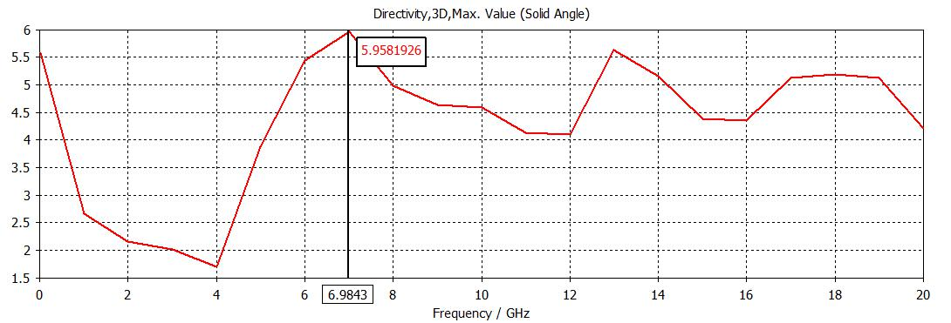

Fig 4.4 Directivity of the designed antenna

The designed antenna has a maximum directivity of 5.95 at the frequency of 6.984GHz.

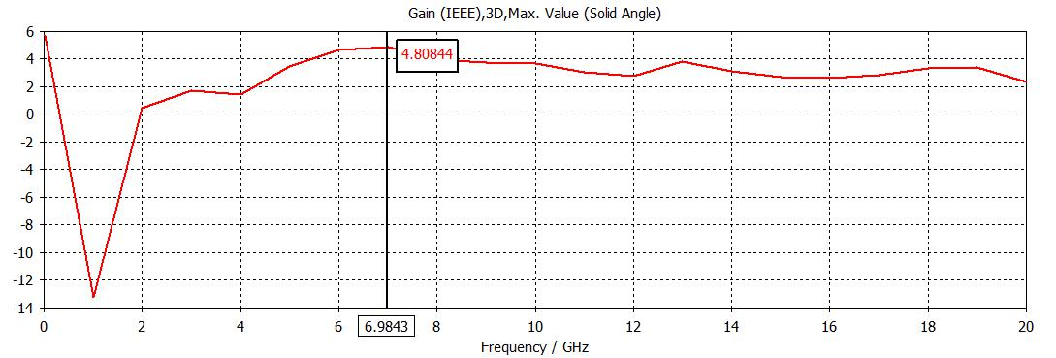

Fig 4.5 Gain of the designed antenna

33

The designed antenna has a maximum gain of 4.808dB at the frequency of 6.984GHz.

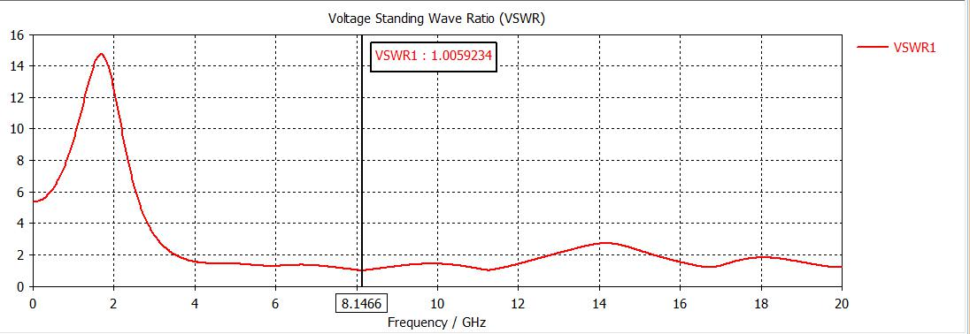

Fig 4.6 VSWR plot of the designed antenna

The designed antenna attains a VSWR of 1.0 which shows the stability of the antenna over the bandwidth range.

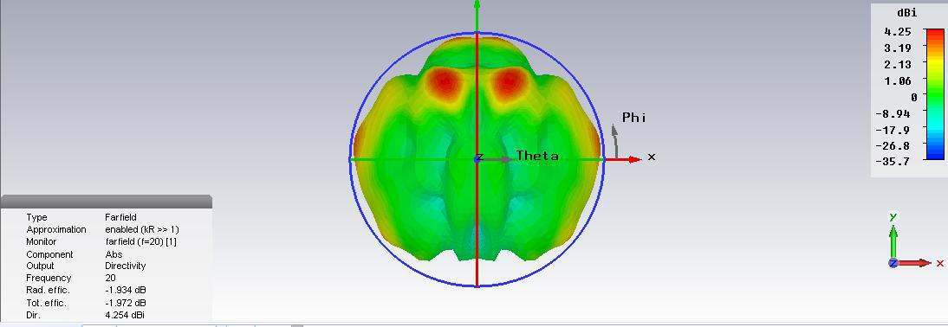

Fig 4.7 radiation pattern of the designed antenna

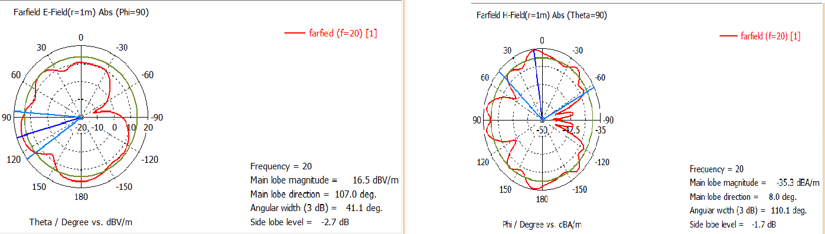

(a) (b)

Fig 4.8 (a) E-Field pattern (b) H-field pattern

34

The above figures show the antenna radiation pattern with the principle E-Plane and H-Plane. In order to increase the bandwidth range and directivity we go for modifications in the ground and the patch and observe the performance.

4.2 **MODIFIED DESIGN OF PENTAGON ANTENNA**

4.2.1 DESIGN OF PENTAGON ANTENNA WITH MODIFIED PENTAGON PATCH

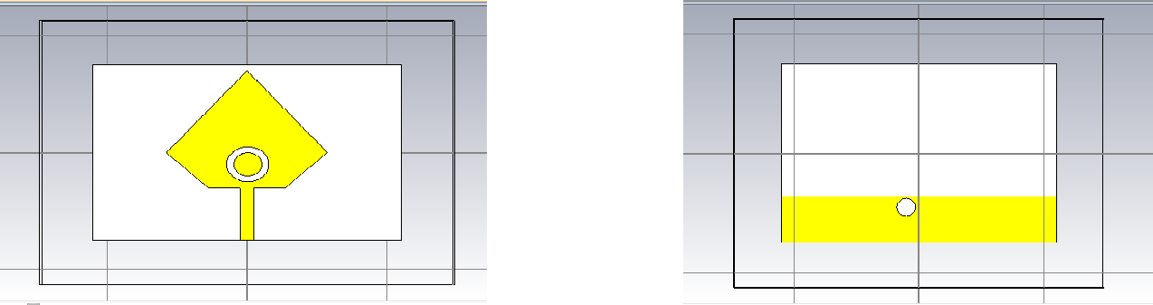

(a) (b)

Fig 4.9 (a) Front view of designed antenna (b) Back view of designed antenna

The design includes rectangular ground and substrate. The patch of the antenna is pentagon shaped. Inside the pentagon shaped patch there is a circle with inner and outer radius of 2mm and 3mm respectively. To the bottom part of the patch, a microstrip feed is attached.

|  |  |
| --- | --- |
| dimensions | Length in mm |
|  |  |
| A | 44 |
|  |  |
| B | 30 |
|  |  |
| C | 20 |
|  |  |
| D | 8.58 |
|  |  |
| E | 2(radius) |
|  |  |

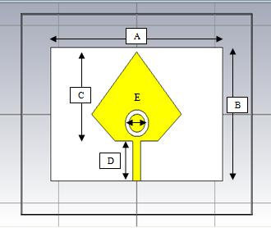

Fig 4.10 patch of antenna with

dimensions

Table 4.2 patch dimensions of proposed antenna

35

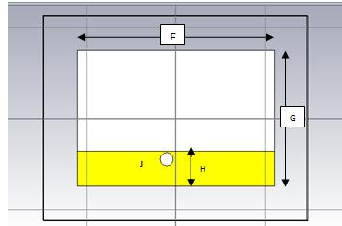

|  |  |
| --- | --- |
| dimensions | Length in mm |
|  |  |
| F | 44 |
|  |  |
| G | 30 |
|  |  |
| H | 7.8 |
|  |  |
| J | 1.5(radius) |
|  |  |

Table 4.3ground dimensions of

Fig 4.11 ground and patch with designed antenna dimensions

4.2.1.1 SIMULATION RESULTS

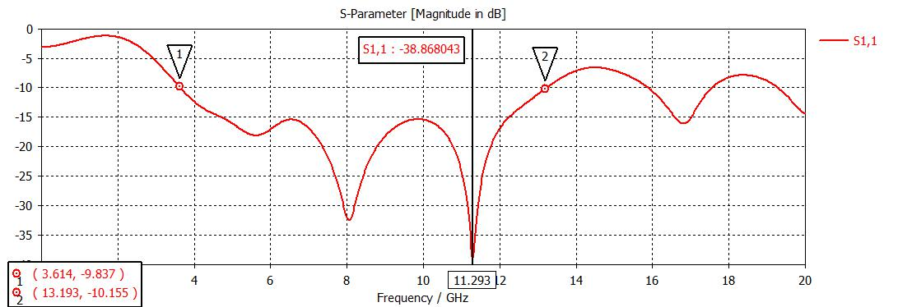

Fig 4.12 reflection coefficient of the designed antenna

From the above graph it is shown that the designed antenna radiates over the bandwidth of 3.614GHz to 13.193GHz with a central operating frequency of 11.293GHz with a maximum return loss.

36

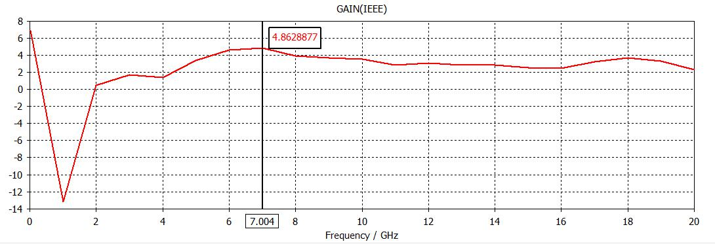

Fig 4.13 gain of the designed antenna

The designed antenna has the maximum gain of 4.862dB at the frequency of 7.004 GHz.

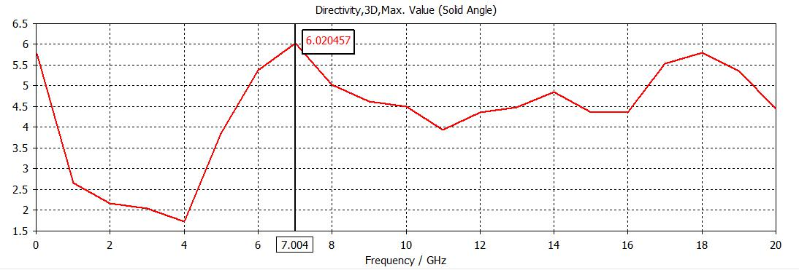

Fig 4.14 Directivity of the designed antenna

The designed antenna has the maximum directivity of 6.020 at the frequency of 7.004 GHz.

37

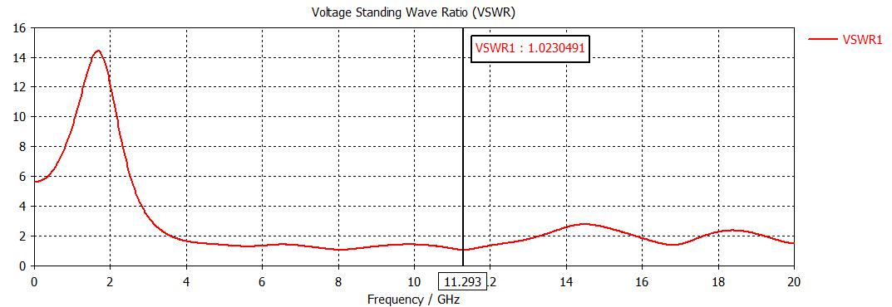

Fig 4.15 VSWR plot of the designed antenna

The designed antenna attains a VSWR of 1.0 which shows the stability of the antenna over the bandwidth range.

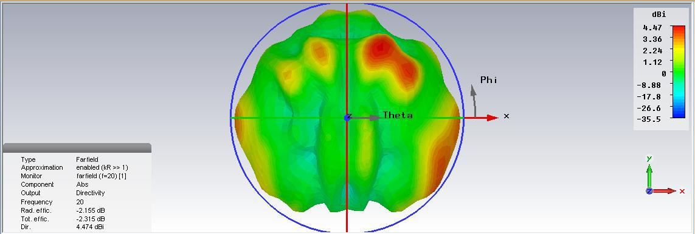

Fig 4.16 radiation pattern of the designed antenna

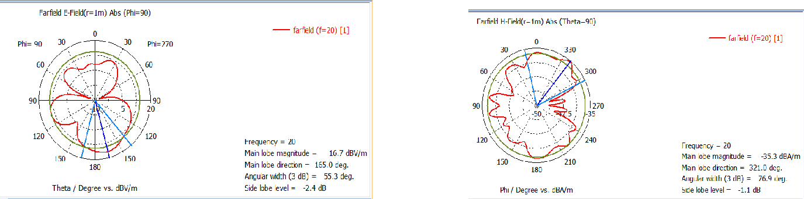

(a) (b) Fig 4.17 (a) E-Field pattern (b) H-field pattern

38

The above figures show the antenna radiation pattern with the principle E-Plane and H-Plane.

**4.3 FABRICATED ANTENNA**

**FRONT VIEW**

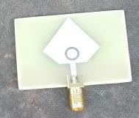

4.9(a) Front view of designed antenna

**BACK VIEW**

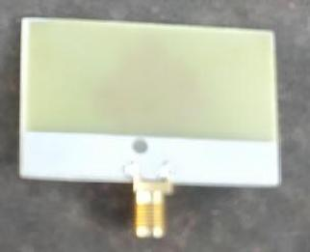

4.9(b) Back view of designed antenna

Fig 4.9(a) and 4.9(b) shows the front and back view of the designed antenna.

39

**4.4 PHANTOM DESIGN**

A head phantom is designed and simulated which has the permittivity and conductivity same as that of the human head. It consists of three layers (skin, skull and brain) and a tumour. At first the phantom was designed without tumour and various parameters are measured. Secondly, the phantom with tumour is designed and simulated. In this case also we measure the various parameters.

40

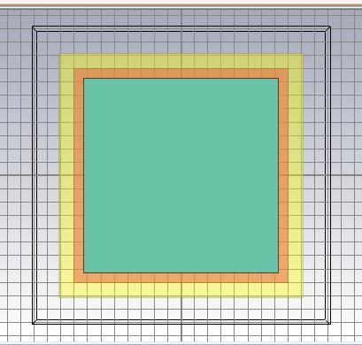

Fig 4.20 head phantom design

Different layers of the head has different permittivity and conductivity values they are as follows

|  |  |  |
| --- | --- | --- |
| LAYERS OF | ELECTRIC | ELECTRIC |
| HEAD | PERMITTIVITY | CONDUCTIVITY |
|  |  |  |
| BRAIN | 49.7 | 0.59 |
|  |  |  |
| SKULL | 17.8 | 0.16 |
|  |  |  |
| SKIN | 46.7 | 0.69 |
|  |  |  |

Table 4.4 Electrical properties of the different layers of the head model

41

4.4.1 PHANTOM MODEL WITHOUT TUMOUR

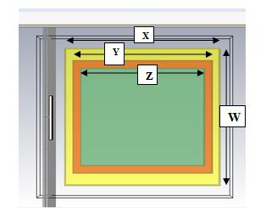

|  |  |  |
| --- | --- | --- |
|  | dimensions | Length in mm |
|  |  |  |
|  | W | 90 |
|  |  |  |
|  | X | 90 |
|  |  |  |
|  | Y | 79 |
|  |  |  |
|  | Z | 72 |
|  |  |  |
| Fig 4.21 phantom design without tumour | Table 4.5-Phantom dimensions | |

Figure 4.21shows the head phantom model. This shows the different layers of head. The inner layer shows the brain, the middle layer shows the skull and the outer layer shows the skin. This model does not contain tumour.

4.4.2 PHANTOM MODEL WITH TUMOUR

4.4.2.1 TUMOUR1

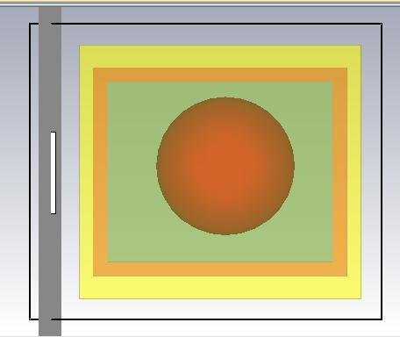

Fig 4.22 Tumour with radius 24.6mm

The above figure shows a Spherical shaped tumour which is present inside the brain with 24.6 mm radius having the electrical permittivity of 70.

42

4.4.2.2 TUMOUR2

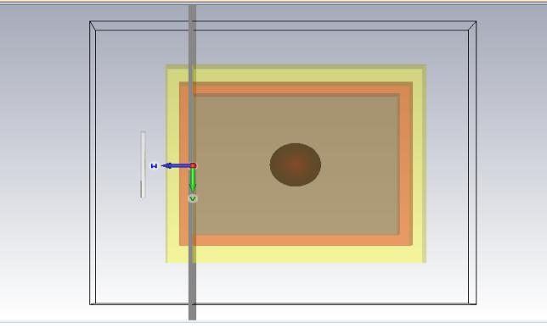

Fig 4.23 Head model contains 10mm tumour which is at a distance of 40mm from antenna

4.4.2.3 Tumour3

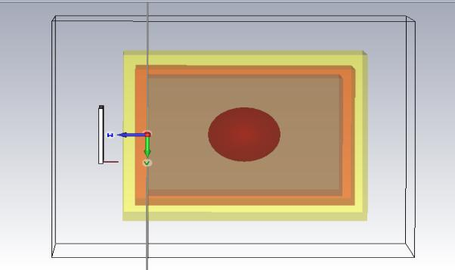

Fig 4.24 Head model contains 15mm tumour at a distance of 40mm from antenna.

4.4.2.4 TUMOUR4

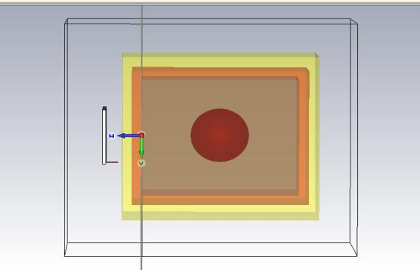

Fig 4.25- Head model contains 24.6mm tumour which is at a distance of 30mm from antenna.

43

4.4.2.5 TUMOUR5

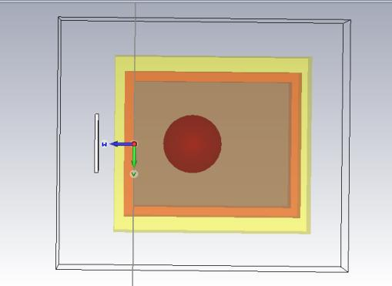

Fig 4.26 Head model contains 15mm tumour which is at a distance of 30mm from antenna.

4.4.2.6 TUMOUR6

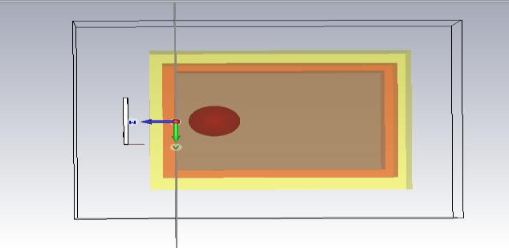

Fig 4.27- Head model contains 10mm tumour which is at a distance of 15mm from antenna.

4.4.2.7 TUMOUR7

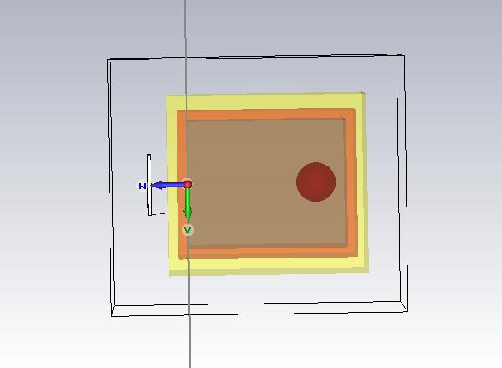

Fig 4.28- Head model contains 10mm tumour which is at a distance of 65mm from antenna.

44

4.4.2.8 TUMOUR8

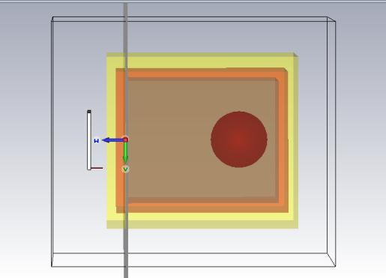

Fig 4.29- Head model contains 15mm tumour which is at a distance of 60mm from antenna.

The above diagram shows the different positions of tumour in the brain. From all these models reflection coefficient values are taken. With the help of this various statistical parameters are analysed.

We can even see the difference in the reflection coefficient values of the head phantom model with and without tumour. It was analysed via MATLAB, which is shown below

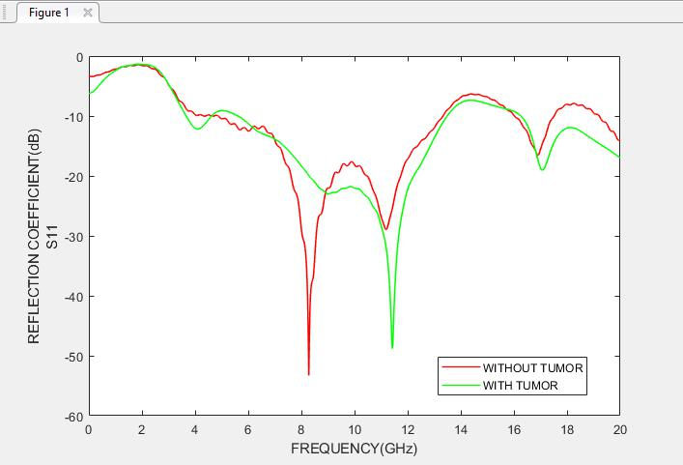

Fig 4.30 reflection coefficient curves of head model with tumour and without tumour.

45

**4.5 ANALYSIS OF BRAIN TUMOUR**

Now, different tumour responses are exported to MATLAB and various

statistical analyses are made which are listed as follows.

MEAN:

The statistical mean refers to the mean or average that is used to derive

the central tendency of the data in question. It is determined by adding all the

data points in a population and then dividing the total by the number of points.

The resulting number is known as the mean or the average.

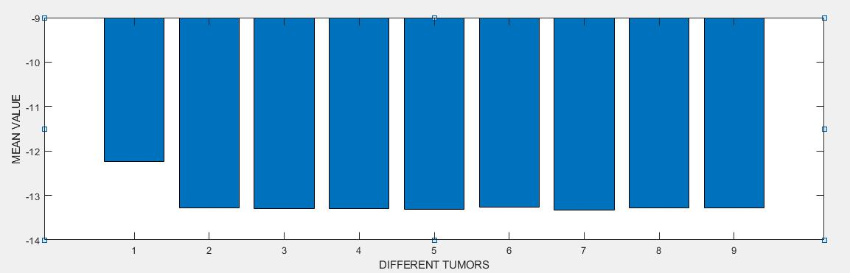

Fig 4.31 mean value of the head phantom without tumour and with different sized tumour.

MEDIAN:

The median is a simple measure of central tendency. To find the median, we arrange the observations in order from smallest to largest value. If there are an odd number of observations, the median is the middle value. If there is an even number of observations, the median is the average of the two middle values.

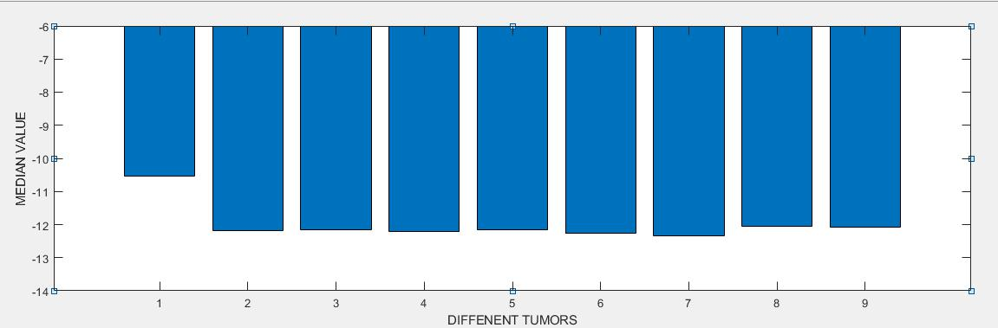

Fig 4.32 median value of the head phantom without tumour and with different sized tumour.

46

MODE:

The mode is a statistical term that refers to the most frequently occurring number found in a set of numbers. The mode is found by collecting and organizing data in order to count the frequency of each result. The result with the highest number of occurrences is the mode of the set.

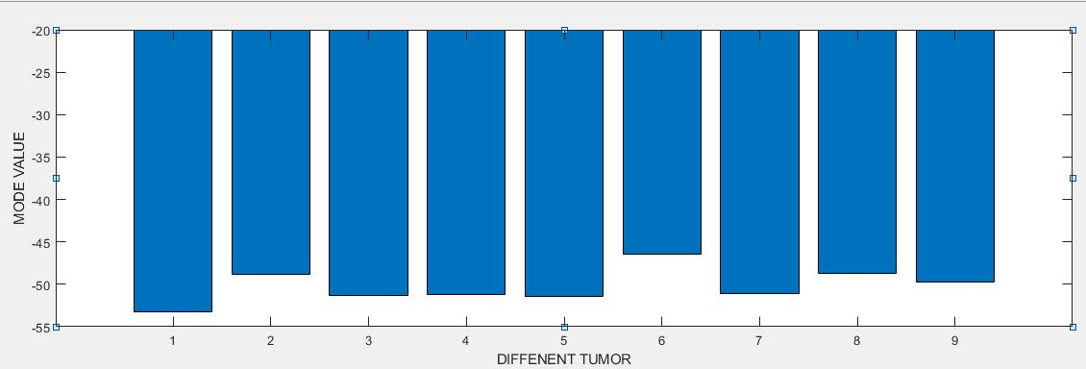

Fig 4.33 mode value of the head phantom without tumour and with different sized tumour.

VARIANCE:

The variance and the closely-related standard deviation are measures of how spread out a distribution is. In other words, they are measures of variability.

The variance is computed as the average squared deviation of each number from its mean.

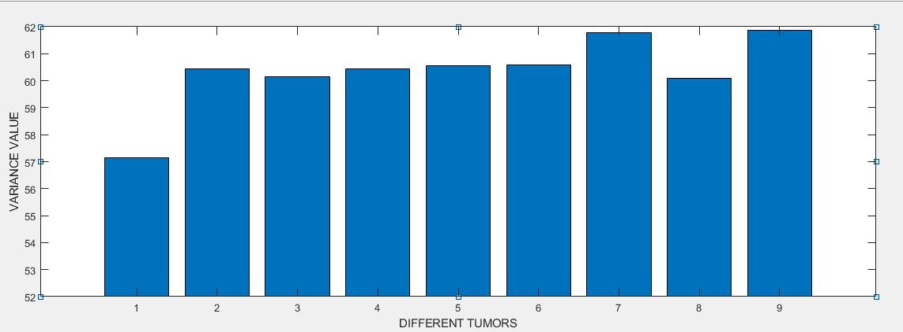

Fig 4.34 variance of the head phantom without tumour and with different sized tumour.

47

STANDARD DEVIATION:

In statistics, the standard deviation is a measure that is used to quantify the amount of variation or dispersion of a set of data values.

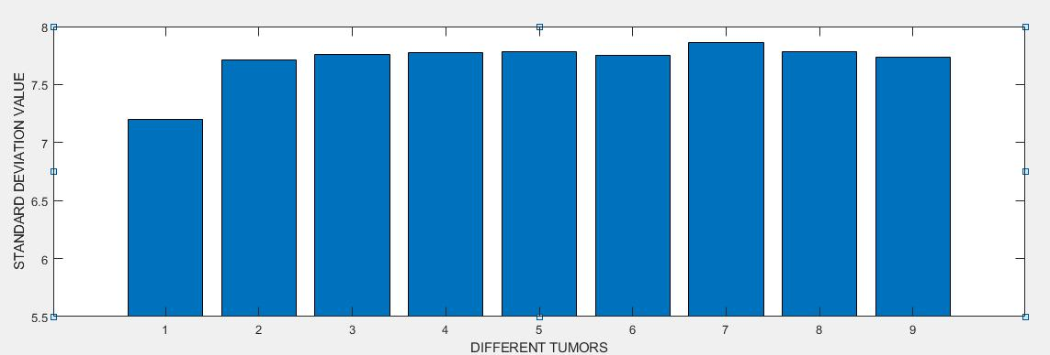

Fig 4.35 standard deviation of the head phantom without tumour and with different sized tumour.

SKEWNESS:

Skewness is asymmetry in a statistical distribution, in which the curve appears distorted or skewed either to the left or to the right. Skewness can be quantified to define the extent to which a distribution differs from a normal distribution.

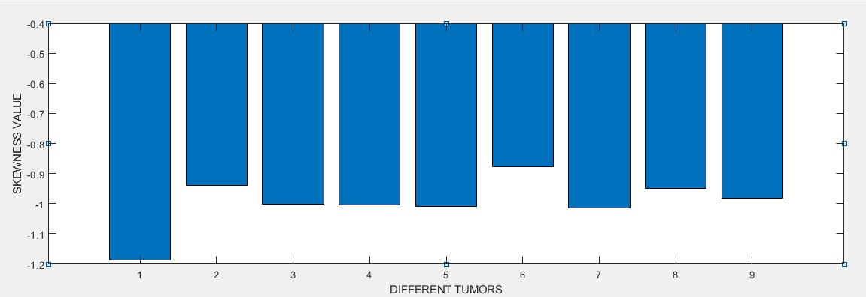

Fig 4.36 skewness of the head phantom without tumour and with different sized tumour.

48

KURTOSIS:

Kurtosis is a measure of the "tailedness" of the probability distribution of a real-valued random variable.

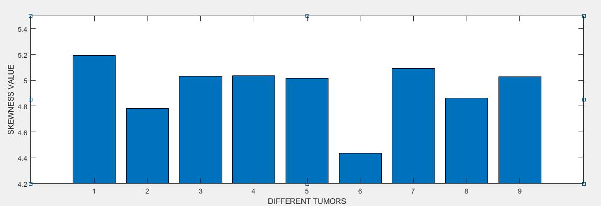

Fig 4.37 kurtosis of the head phantom without tumour and with different sized tumour.

MINIMUM VALUE:

The minimum value is the smallest value in the data set.

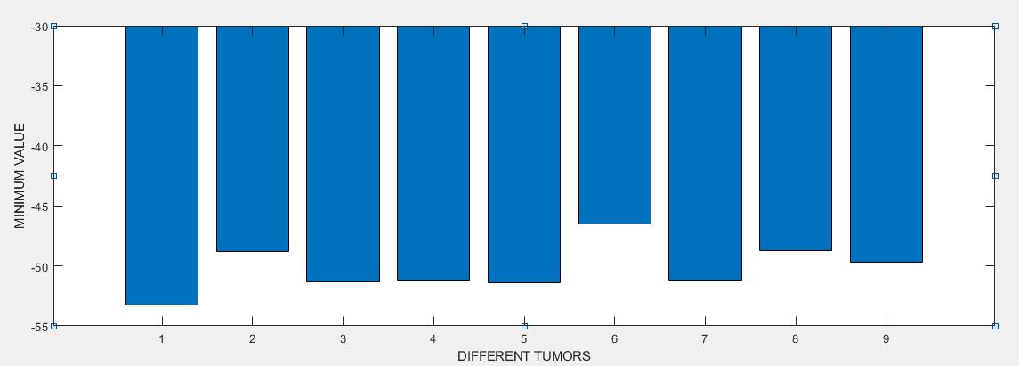

Fig 4.38 minimum value of the head phantom without tumour and with different sized tumour.

49

MAXIMUM VALUE:

The maximum value is the largest value in the data set.

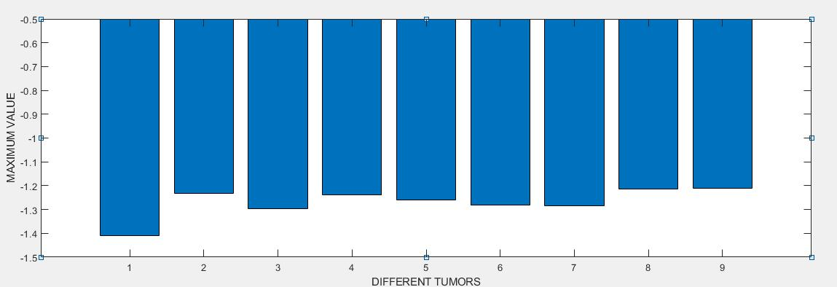

Fig 4.39 maximum value of the head phantom without tumour and with different sized tumour.

RMS VALUE:

The RMS value of a set of values (or a continuous-time waveform) is the square root of the arithmetic mean of the squares of the values, or the square of the function that defines the continuous waveform.

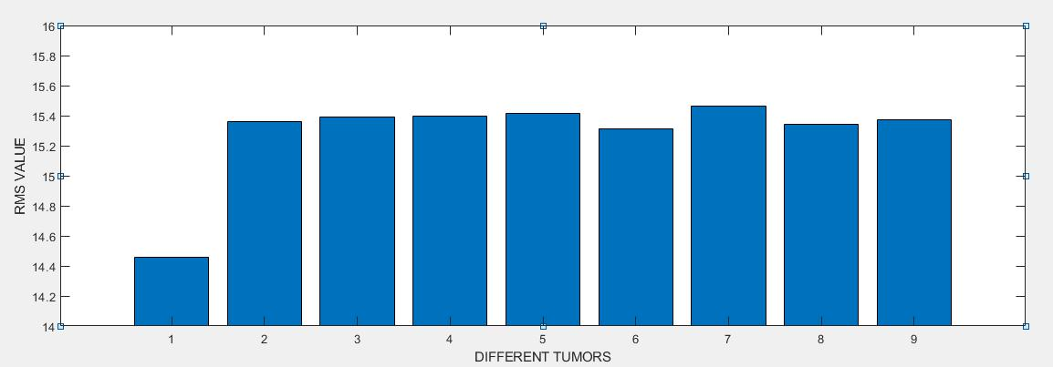

Fig 4.40 rms value of the head phantom without tumour and with different sized tumour.

50

CREST FACTOR:

Crest factor is usually expressed in decibels, so it's defined as the level difference between the RMS and the peak value of the waveform.

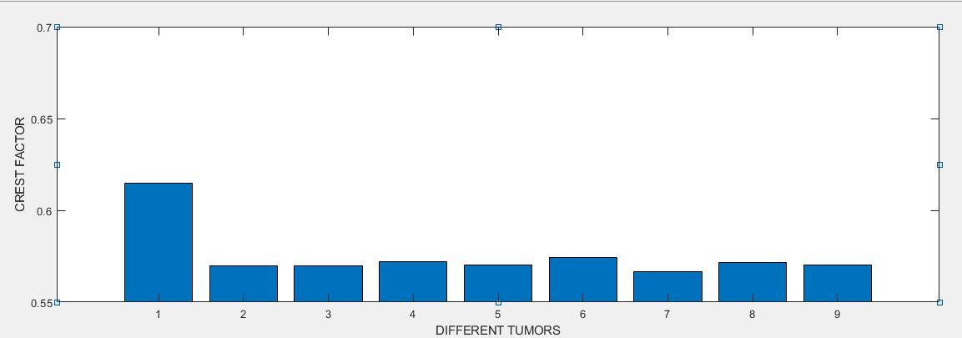

Fig 4.41 crest factor of the head phantom without tumour and with different sized tumour.

COVARIANCE:

Covariance is a measure of how changes in one variable are associated with changes in a second variable.

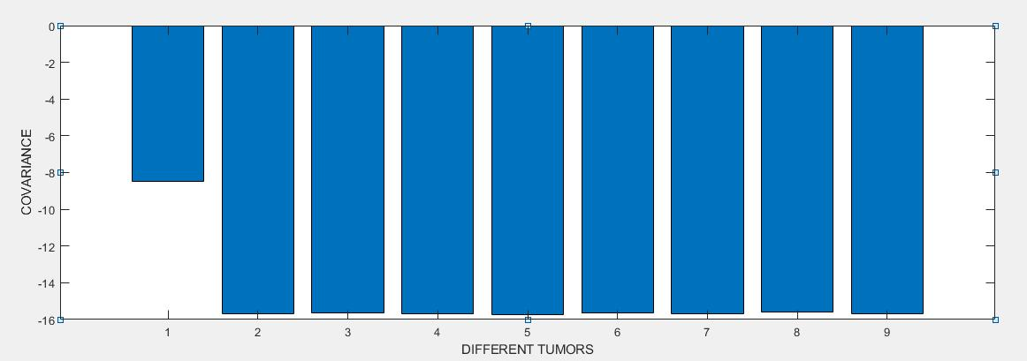

Fig 4.42 covariance of the head phantom without tumour and with different sized tumour.

51

CORRELATION COEFFICIENT:

The correlation coefficient measures the strength and direction of a linear relationship between two variables on a scatter plot.

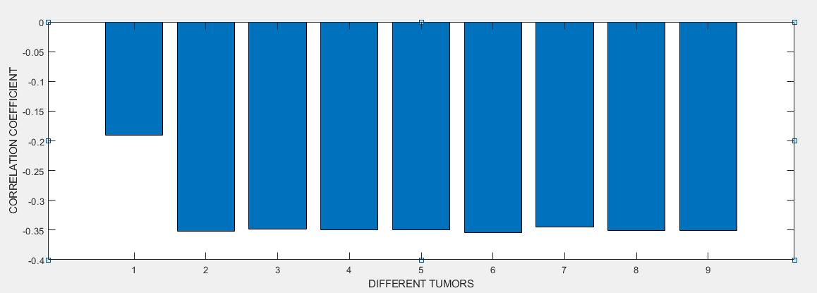

Fig 4.43 correlation coefficient of the head phantom without tumour and with different sized tumour.

|  |  |
| --- | --- |
| DIFFERENT | DESCRIPTION |
| TUMOURS |  |
| 1 | Without tumour |
| 2 | With tumour(24.6mm radius at a distance of 40mm from |
|  | antenna) |
| 3 | With tumour (10mm radius at a distance of 40mm from |
|  | antenna) |
| 4 | with tumour (15 mm radius at a distance of 40mm from |
|  | antenna) |
| 5 | with tumour (24.6mm radius at a distance of 30mm from |
|  | antenna) |
| 6 | with tumour (15mm radius at a distance of 30mm from |
|  | antenna) |
| 7 | with tumour (10mm radius at a distance of 15mm from |
|  | antenna) |
| 8 | with tumour (10mm radius at a distance of 65mm from |
|  | antenna) |
| 9 | with tumour (15mm radius at a distance of 60mm from |
|  | antenna) |
|  | Table 4.6 Analysis with different tumours |
|  | 52 |

**CHAPTER 5**

**RESULT AND CONCLUSION**

**5.1 CONCLUSION**

Thus the proposed model includes the design and simulation of UWB pentagon antenna with little modifications in patch and ground in order to improve the bandwidth and directivity and it is fabricated on FR-4 substrate. The human head phantom is designed with and without tumour, tested with the proposed antenna. The various response (with and without tumour) observed by the antenna and analysed using MATLAB. From the response of simulated reflection coefficient we analysed the statistical differences between the normal head and tumorous head. From these result we were able to accurately find the presence of tumour.

**5.2 FUTURE WORK**

The future work of this project is to find the accurate position and size of tumour. By using different material as substrate the gain, return loss, directivity can be further increased in order to analyse very minute sized tumours.

53

**APPENDIX**

**CST**

The antenna was designed by using CST microwave studio 2014.



Fig 1 create a project in CST microwave 2014

Click on create new project then select RF & Microwave & optical part in the pie chart then click antenna option.



Fig 2 create a new template

54

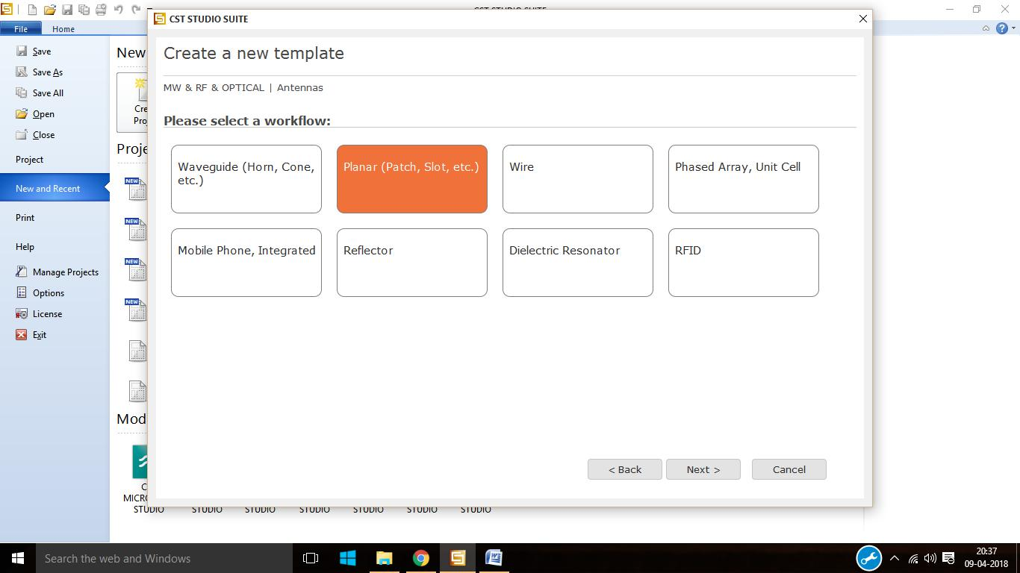

Fig 3 Selection of work flow



Fig 4 select the required domain

55



Fig 5 select the required units



Fig 6 minimum, maximum frequency and field monitors selection

56

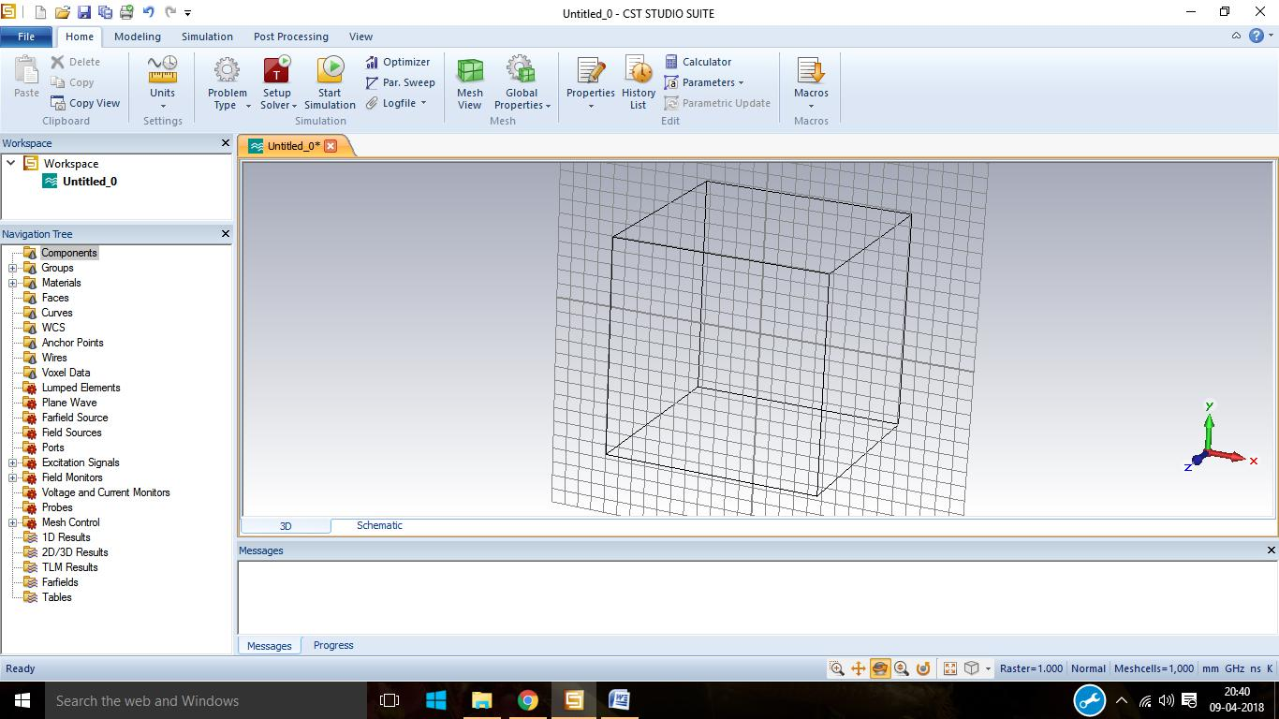

Fig 7 Working plane

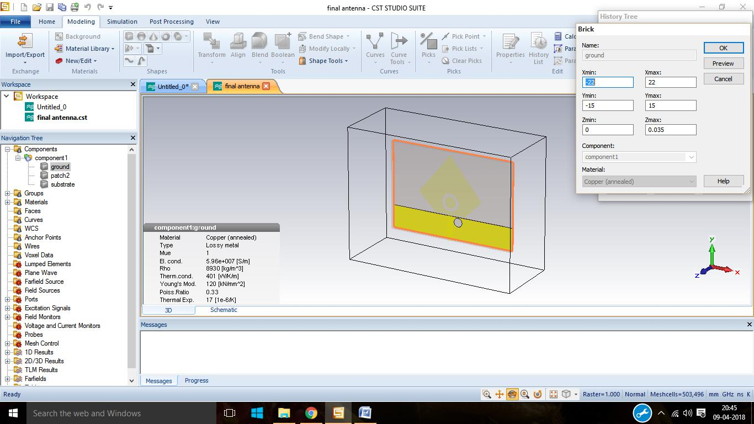

Fig 8 proposed model back view

57

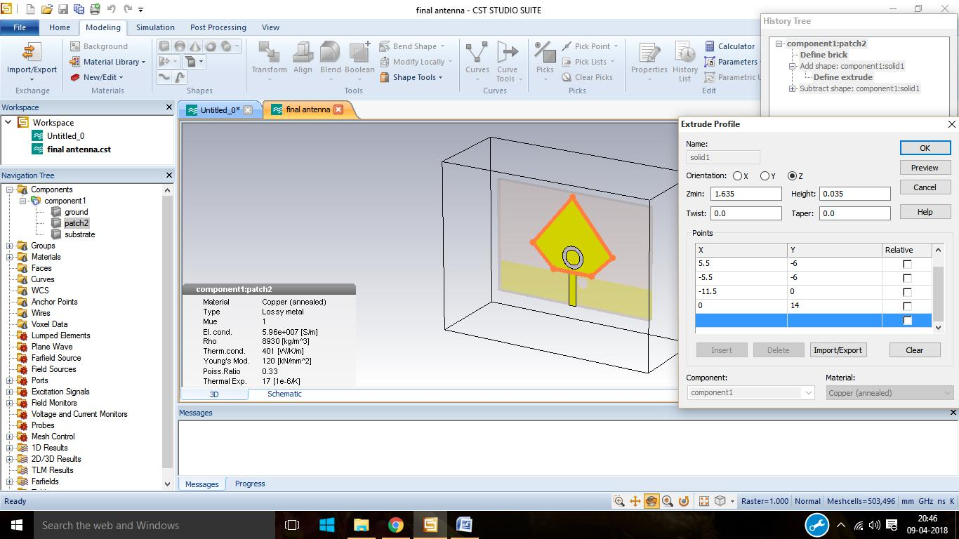

Fig 9 proposed antenna front view

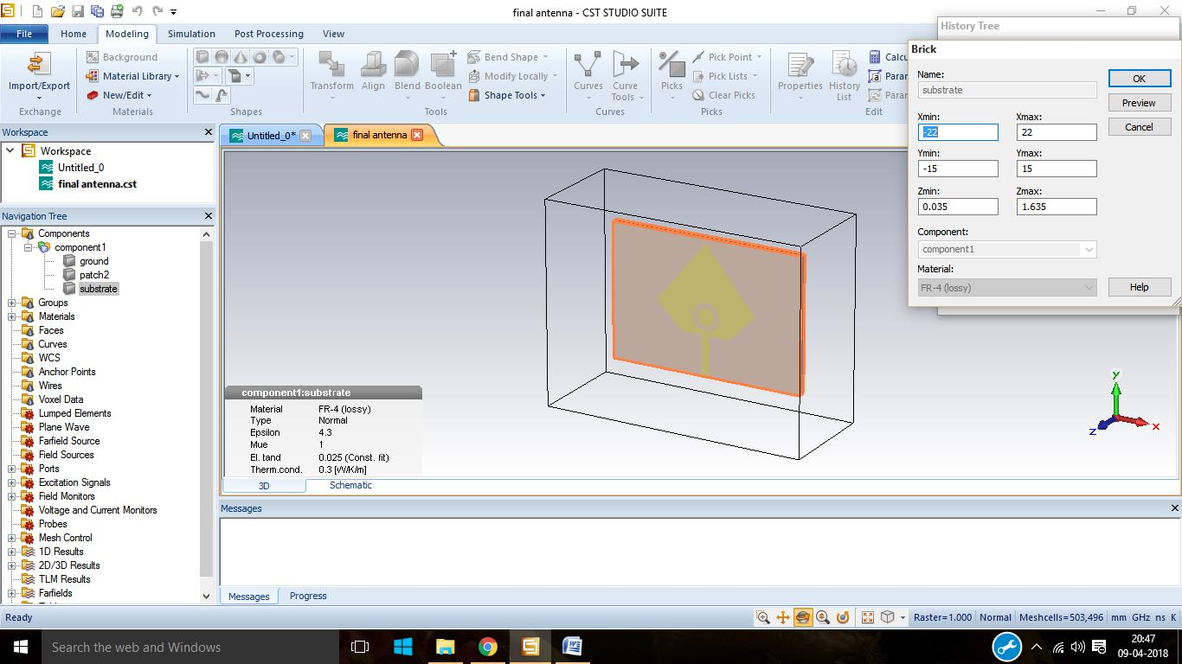

Fig 10 Substrate of the designed antenna

58

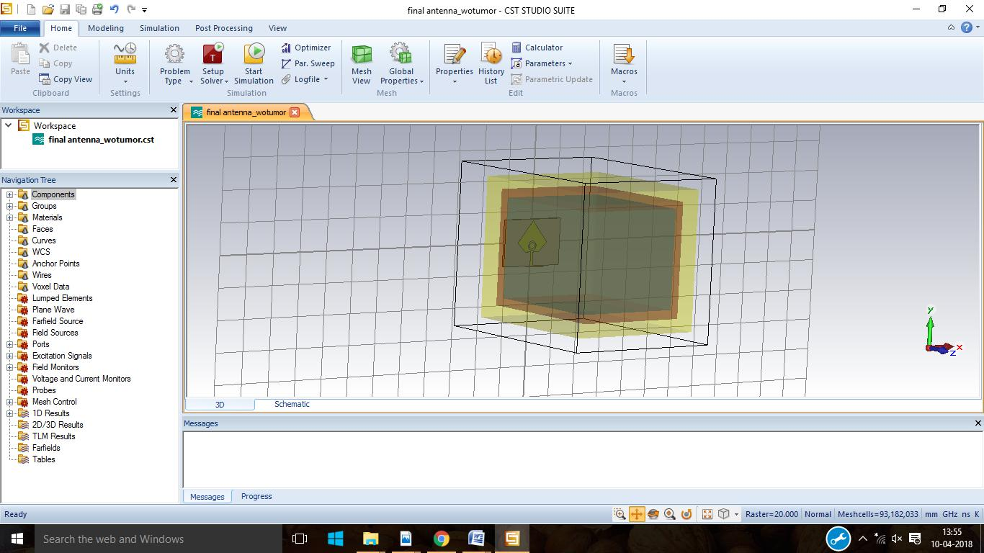

Fig 11 designed antenna radiating into the head model without tumour

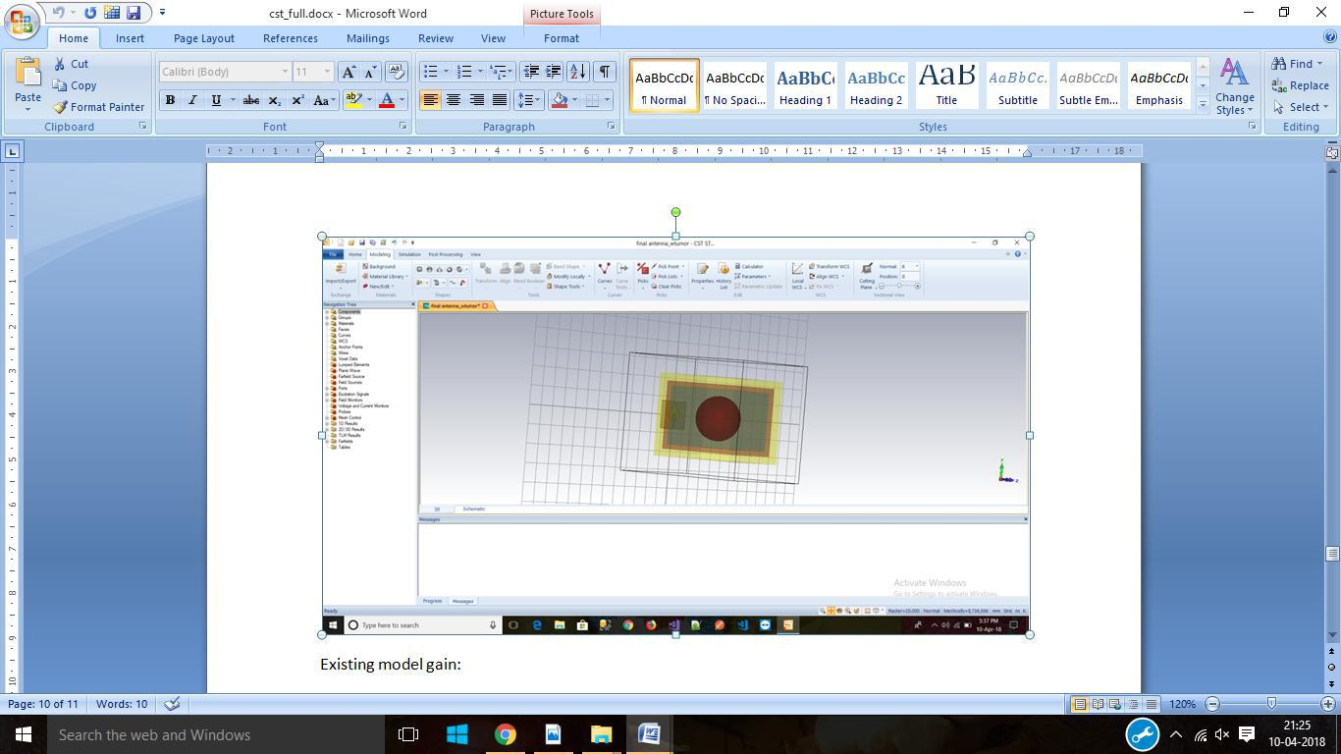

Fig 12 designed antenna radiating into the head model with tumour

59

**REFERENCES**

1. Adhitya Satria Pratama, Muhammad Firdaus S. Lubis, Fitri Yuli Zulkifli,

Eko Tjipto Rahardjo” A UWB Antenna for Microwave Brain Imaging”

Universitas Indonesia Kampus UI Depok, West Java, Indonesia, 2015.

1. B.Mohammed, a.Abbosh, B.Henin, P.Sharpe, “Head Phantom for Testing Microwave System for Head Imaging,” CIBEC, Cairo, 2012.
2. D.Ireland and M.Bialkowski, “microwave head imaging for stroke Detection,” School of ITEE, University of Queensland St.Lucia,

Brisbane, Australia, 2011.

1. E . Pancera, “Medical applications of the Ultra Wideband technology,”

2010 Loughborough Antennas and Propagation Conference (LAPC), pp.52-56, 8-9 Nov. 2010

1. E.Widmaier, H. Raff, K Strang, and A. Vander, “Human physiology: the mechanisms of body function,” Mcgraw Hill, 2008.
2. Eng. M. A. Shokry, Prof. Dr. A. M. M. A. Allam “UWB Antenna for Brain stroke and Brain Tumour Detection“ Faculty of Information

Engineering and Technology German University in Cairo Cairo,Egypt, 2016.

1. F.Balsiger, “Brain Tumour Volume Calculation”, Linkoping university,July 2012
2. F.Balsiger, “Brain Tumour Volume Calculation”, Linkoping university,

July 2012.

1. Haoyu Zhang, Ahmed O. El-Rayis, Nakul Haridas, Nurul H. Noordin,

Ahmet T. Erdogan, Tughrul Arslan “A Smart Antenna Array for Brain Cancer Detection” Advanced Smart Antenna Technologies Research Group, School of Engineering, The University of Edinburgh, EH9 3JL, UK, 2011

60

1. Haoyu Zhang, Brian Flynn, Ahmet T. Erdogan, Tughrul Arslan”

Microwave Imaging for Brain Tumour Detection Using an UWB Vivaldi

Antenna Array” Advanced Smart Antenna Technologies Research Group,

School of Engineering, The University of Edinburgh, EH9 3JL, UK, 12-13 November 2012.

[11]. M. Garcia and A. Jemal, “Global Cancer Facts and Figures 2011,”Atlanta, GA: American Cancer Society, 2011

1. M. Garcia and A. Jemal, “Global Cancer Facts and Figures 2011,”Atlanta, GA: American Cancer Society, 2011.
2. M.A.Shokry, A.M.M.A.Allam, “Planar Spiral Antenna for Brain strike detection,” EuCAP, Lisbon, 2015.
3. Ma, H., J. Ly, and G. A. Donnan, “ TIA and stroke: A management guide for GPs,” Medicine Today, Vol. 7, No. 5, May 2006.
4. Mohammed A. Alzabidi, Maged Aldhaeebi and Ibrahim Elshafiey

“Optimization of UWB Vivaldi Antenna for Tumour Detection“

Department of Electrical Engineering King Saud University Riyadh, Saudi Arabia,2013.

1. World Stroke Academy, “Let’s talk about a stroke diagnosis,” vol. 2011, no. 20 May, 2007.
2. Y.Done-Sik, K.Boneg-Seok, C.Hyung-Do, L.Aekyoung,P.Jeoy.Ki, “The Dielectric properties of cancerious”, Chungnam National University,

Daejeon 305-764, Korea.

1. Y.Rahmat-Samii and J.Kim, “Implanted Antennas in Medical WirelessCommunication”, University of California at los Angeles,

Morgan & Claypool, 2006.

61